NETWORKED LEARNING - 2008
Sani Beach Hotel, Halkidiki, Greece.
5th and 6th May 2008
Arrival Information

Sightseeing
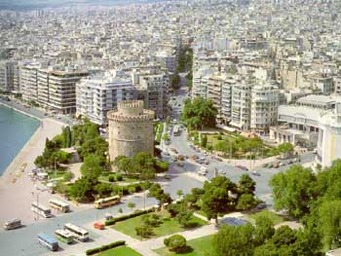
Thessaloniki, named after Alexander the Great’s sister, is the second largest city in Greece with a population of over one million citizens. Thessaloniki is an industrial and commercial center with the White Tower as its cultural landmark. For the newcomers there are a variety of interesting places to go and see along with a vibrant music scene, theatrical performances and traditional Greek food and nightlife. For more information and a city map please visit: http://www.thessalonikicity.gr

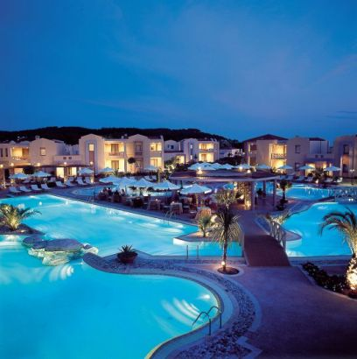
Halkidiki is one of the most fantastic, breathe taking summer resorts. It is located in the south eastern portion of Central Macedonia and every year invites both business people and tourists. Poligiros is the capital of Halkidiki and is 69km from Thessaloniki. On a map it is easily distinguished as it looks like one of three fingers with Kassandra (where SANI Resort is situated), Sithonia and Agion Oros. Many holiday makers find Halkidiki one of the most heavenly places and a must visit. For information and a map direction please visit:
http://www.gohalkidiki.com/home_en.asp

Conference Transportation

Imperial Palace Hotel, Thessaloniki

For delegates who have arrived early a bus will leave the Imperial Palace Hotel at 11.50am on Sunday 4th May, this will travel via the Airport (12.20pm pick up) onto the Sani Beach Hotel.

Note: Conference transportation is not available prior to Sunday 4th May. Delegates arriving early should use taxis to travel to their relevant hotels. Approximate costs are:
To Imperial Palace: 15 -20 Euro
Sani Beach Hotel : 60 – 70 Euro (Ask the driver the price at the airport.)
Sunday 4th May - Thessaloniki Airport – Sani Beach Hotel

Thessaloniki is a relatively small airport and our conference representatives will be on hand Sunday 4th May to assist delegates with their transportation from the airport to the Sani Beach Hotel

Coaches will leave the airport at the following times:

12.20
15.00

Taxis are available at the airport and if your flight doesn’t fit with one of these times then please contact us nlc2008@teithe.gr we can then try and put you in contact with other delegates arriving at a similar time so you have the opportunity to share a taxi.
Approximate cost: As above

By train: Halkidiki has no railway service You can either hire a car or take a taxi to Halkidiki.

Wednesday 7th May - Sani Beach Hotel – Thessaloniki Airport

The journey time to the airport is approximately 1 hour. Coaches will leave the Sani Beach Hotel at:

08.30
13.00 – Times to be confirmed- Check at the Conference Reception.

If your return flight doesn’t fit with one of these times then please speak to the Conference Reception on Monday 5th and we can then try and put you in contact with other delegates leaving at a similar time so you have the opportunity to share a taxi.

Note: Rooms must be vacated by 12.00 – Luggage can be stored by the hotel until departure.

All accommodation booked prior to and after the conference should be paid for at the relevant hotel reception.

Registration

Conference registration will take place in the Sani Beach Hotel Conference Reception on Sunday from 18.00 – 20.00 & Monday from 08.30 – 09.00. We would ask delegates who arrive in time on Sunday to register on Sunday evening.

Hotel Resort

At the hotel resort you will find a variety of shops, including a newsagent, supermarket, and boutiques and shops to purchase clothes, gifts, books, cosmetics and photographic materials.
Contact Information:

Imperial Palace Hotel
Address: 13 Antigonidon str, 54623, Thessaloniki
Phone: +30 2310 508300
Fax: +30 2310 548698
Email: imper10@otenet.gr
All rooms have Internet access

Sani Beach Hotel
Address: 630 77 Kassandra, Halkidiki, GREECE
Phone: ++30.23740.99400
Fax: +30.23740.99508
Email: info@saniresort.gr
Internet access in the Lobby

Urgent Messages/Contact
Urgent messages can be left on the Conference
Mobile Phone + 30 6937 691784 (This is a Greek mobile)
Messages will be displayed on the Conference Reception Desk or you can call the Sani Resort Hotel Reception on: ++30.23740.99402

Other Useful Information

http://www.meteo.gr (Weather broadcast)

http://www.hnms.gr/hnms/english/index_html? (Weather broadcast)

http://www.ekathimerini.com/ (Latest news)

http://world.altavista.com/tr (English - Greek Language Translator)

http://www.xe.com/ucc/ (Currency converter)

http://www.saloniki.org/ (Thessaloniki news and events)

http://www.hertz.gr/hertz_en/ Car Hire
http://www.sixt.gr/en/

